Microbe – Plant interaction: Symbiotic Plant interaction

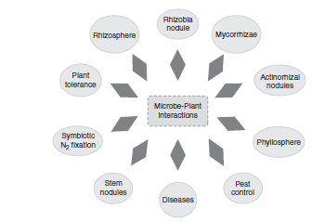
Earth is richly populated with plants, and many different types of microorganisms grow in close association with them. While microbial activities detrimental to plant growth may be the most obvious, microorganisms are also beneficial to plants. Microorganisms may provide some nutritional benefit to a plant host, and this would result in increased plant growth. Over time different interactions between microorganisms (bacteria, fungi, or algae) and plants have been identified, and several of these activities are indicated in Figure 1.

Fig 1. Model indicating various plant – microbe interactions

Perhaps one of the most obvious environments for microbe–plant interactions occurs in soil. Plant roots have a lot of extensions from the central root, and bacteria may become localized on the root surface.
In general, plants benefit from two types of microbe–plant associations:
(1) highly specialized interaction, where there is considerable specificity found in mutalistic activities; and
(2) commensalism resulting from nutrient secretion from plants when bacteria and fungi grow in close proximity to the roots but providing no apparent benefit to the plant.

The two best characterized symbiotic systems are the fungus–root system and the bacterium–root nodule system. The beneficial aspects of plant–microbe symbiosis are well established in that the plants provide carbon material to support growth of the microbes and the bacteria or fungi promote plant growth by enhancing mineral uptake. With commensalism, the activity is less obvious than with symbiosis in that various chemicals are secreted from the leaves or roots of growing plants and these compounds stimulate the growth of bacteria.
SYMBIOTIC NITROGEN FIXATION
Symbiotic nitrogen fixation is accomplished by bacteria of the genus Rhizobium in association with legumes (plant that bear seeds in pods, e.g., soybeans, clover and peas). The partners is a symbiosis are called symbionts, and most nitrogen fixing bacterial symbiont of plant are collectively called Rhizobia, derived from the name of a major genus, Rhizobium. Rhizobia can grow freel in soil or infect leguminous plant . infection of legume roots by Rhizobia leads to the formation of root nodule in which the bacteria fix gaseous nitrogen.

In the absence of its bacterial symbiont, a legume cannot fix nitrogen. Rhizobia, can fix nitrogen when grow in pure culture under microaerophilic condition (a low oxygen environment is necessary because nitrogenase are activated by high level of O₂).
In nodule, O₂ level are controlled by the O₂-binding protein Leghemoglobin. Production of these iron-containing protein in healthy N₂-fixing nodules is induced through the interaction of the plant and bacterial partners.
Leghemoglobin function as an “oxygen buffer”, cycling between the oxidized (Fe³⁺) and reduced (Fe²⁺) forms of iron to keep unbound O₂ within the nodule low.
A group of related legumes that can be infected by a particular rhizobial species is called cross inoculation group for example, clover group, bean group, an alfafa group and so on. If legumes are inoculated with the correct rhizobial strain, leghemoglobin – rich, N₂-fixing nodules develop on their roots.

Bacteria are specific for a legume species, and formation of the root nodule is the result
of a unique differentiation process. A model representing some of the steps involved in
the formation of a nitrogen-fixing nodule are presented in Figure 2, and the individual
steps are summarized as follows:
1. The legume root secretes specific chemicals known as flavonoids and these signaling molecules attract rhizobia growing in the rhizosphere.
2. The flavonoids also induce transcription of nod genes in the rhizobial genome to produce lipochitin oligosaccharides, called Nod factors.
3. The plant root recognizes the chemical structure of the Nod factors, and these lipochitin oligosaccharide molecules are taken up by legume receptor kinases. The Nod factors activate the plant hair roots, and this recognition is responsible in part for the specificity between the host and legumes.
4. The symbiotic bacteria attach onto the root hairs and enter into the root by a process
known as root infection.
5. The bacteria produce a lipopolysaccharide capsule that enables the rhizobia to evade plant defense systems and enter the root by a structure designated as the infection thread.
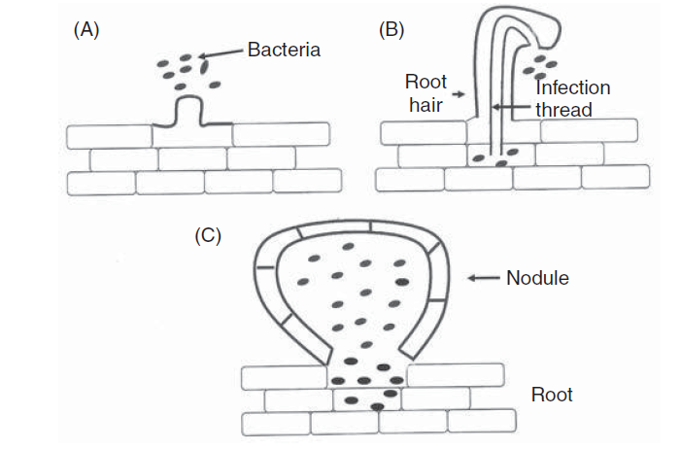
Fig 2. Development of root nodule in legume: (A) the sequence of events initiated by
root hairs secreting a chemical to attract bacteria; (B) an infection thread in established to carry bacteria into the root cortex; and (C) nodule formation occurs. Additional information is provided in the text.

FUNGUS-ROOT SYSTEM
Mycorrhizae are mutualisms between plant roots and fungi in which nutrients are transferred in both directions. The fungus transfers nutrients—in particular, phosphorus and nitrogen—from the soil to the plant, and the plant in turn transfers carbohydrates
to the fungus. These mutualisms are harnessed in agricultural applications. From fungal spores produced in culture or from root scrapings of infected plants, soil inoculants are produced that enhance plant growth.

Classes of Mycorrhizae
There are two classes of mycorrhizae. In ectomycorrhizae, fungal cells form an extensive sheath around the outside of the root with only a slight penetration into the root tissue itself. In endomycorrhizae, a part of the fungus becomes deeply embedded
within the root tissue.
Ectomycorrhizae are found mainly on the roots of forest trees, especially conifers, beeches, and oaks, and are most highly developed in boreal and temperate forests. In
such forests, almost every root of every tree is mycorrhizal. The root system of a mycorrhizal tree such as a pine (genus Pinus) is composed of both long and short roots. The short roots, which are characteristically dichotomously branched in Pinus show typical fungal colonization, and long roots are also frequently colonized.

Most mycorrhizal fungi do not catabolize cellulose and other leaf litter polymers. Instead, they catabolize simple carbohydrates and typically have one or more vitamin
requirements. They obtain their carbon from root secretions and obtain inorganic minerals from the soil. Mycorrhizal fungi are rarely found in nature except in association with roots, and many are probably obligate symbionts.

Despite the close symbiotic association between fungus and root, a single species of tree can form multiple mycorrhizal associations. One pine species can associate with over 40 species of fungi. This relative lack of host specificity allows ectomycorrhizal mycelia to interconnect trees, providing linkages for transfer of carbon and other nutrients between trees of the same or different species. Nutrient transfer from well-illuminated overstory plants to shaded trees is thought to help equalize resource availability, subsidizing young trees and increasing biodiversity by promoting the coexistence of different species.

SYMBIOTIC ASSOCIATIONS WITH CYANOBACTERIA
Cyanobacteria are found in a variety of environments, including those in symbiotic associations with plants. Azolla is an aquatic fern that contains bilobed leaves attached to a stem and is found floating in freshwater. This tiny plant has a symbiotic association with Anabaena azollae, where the cyanobacteria fixes atmospheric nitrogen and Azolla provides carbohydrates. The cyanobacteria are found in a cavity between the ventral and dorsal epidermal layers of the leaf. The cyanobacteria grow as a microcolony in the plant
Azolla has long been used to enrich the nitrogen level of rice fields and is often used as
a fertilizer known as “green manure.”

References
- Microbial ecology, Larry L Barton and Diana E Northup, Chapter 7: Interactions between microorganisms and plants
- Microbiology, Michael J. Pelczar, JR., Chapter 25: Microbiology of soil
- Brock biology of microorganisms, Chapter 22: Microbial symbioses

